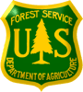

Date: Applicant Name:
Hawaiʻi Experimental Tropical Forest Educational Activity Permit Application
Pu‘uwa‘awa‘a
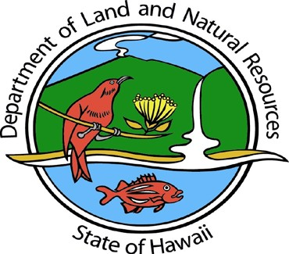
This application may only be used for activities that are chaperoned by a Hawaiʻi State or Forest Service employee/representative.
Please complete all sections of application - incomplete applications will not be accepted. Application must be submitted 30 days prior to requested date(s). Email completed applications to: napuuconservation@gmail.com. Attach additional pages as necessary.

Organization/Affiliation:

Address:

Phone Number:

Email:

Emergency Contact (not going on trip) Name:
Phone number:

Email:

Destinations within the HETF: Puʻuwaʻawaʻa – Sub-Units (see attached map):

Date(s) Requested:
Forest Reserve
Forest Bird Sanctuary
Kīholo State Park

If overnight, indicate proposed facility accommodations:
Lake House
Meeting House
Protea Cabin

Purpose:
Service Trip ( %),
Education ( %) or
Other

Indicate % of time dedicated to trip purpose if both service and education are selected.
State or Forest Service Chaperone (name, telephone #, email):
Activity Description (include points of interest and service project details):

Subject areas to be discussed (attach agenda with names and affiliations of associated resource speakers if available):

Total group number (including group leaders): Number of Adults (18 or older):
Additional Comments or Questions:
Total number of Vehicles:

Number of minors (younger than 18):

Permit standard conditions:
- The permittee shall adhere to the specifications given in the permit application.
- Disturbance of vegetation and wildlife shall be avoided as much as possible.
- Applicants are required to ensure that personnel have first aid training, use appropriate safety equipment, and carry a first aid kit. In certain circumstances, additional safety equipment, such as fire extinguishers, may be required.
- Precautions shall be taken to prevent introductions of plants or animals not naturally present in the area. The permittee is responsible for making sure that participants’ clothing, equipment, and vehicles are free of seeds or dirt to lessen the chance of introducing any non-native plants or soil animals. Should an infestation develop attributable to the permittee, the permittee is responsible for eradication by methods specified by the Department of Land and Natural Resources, as recommended by the HETF Research Technical Committee.

- Rapid ‘Ōhi‘a Death (ROD) - To reduce the spread of the fungal disease Rapid ʻŌhiʻa Death (i.e. ROD or Ceratocystis fimbriata), Permittee shall take the following precautions every time the HETF is entered.
  - Vehicles used to access the HETF shall be thoroughly power-washed with car-washing detergent (including the undercarriage and tires) before entering so as not to carry contaminated soil, plant matter, or fungal spores to healthy forests.
  - Soles of footwear shall be brushed and sprayed with 70% isopropyl alcohol; tools, and clothing must be cleaned thoroughly before entering the HETF to prevent contaminated soil, plant matter, or fungal spores from being transported into the HETF per the guidance at the Internet site: www.rapidohiadeath.org.
  - Unless permitted, no wood or plant material of ʻōhiʻa trees shall be transported to or from the HETF (or within these areas); Ceratocystis fimbriata may remain viable for over a year in dead wood. Cutting leaves, branches, bark or other material off of ʻōhiʻa trees for scientific purposes can create a wound site making trees more susceptible to ROD. For current information on known ROD-infected areas, please go to at the Internet site: www.rapidohiadeath.org.
  - If dead or dying ʻōhiʻa trees are observed in the HETF (especially if trees retain dead or dying leaves), Permittee shall notify the HETF coordinator immediately at SM.FS.hetf@usda.gov of the number of trees affected, locations (latitude and longitude or UTM coordinates taken on a GPS are best), and the status of the trees (dead, dying, partially dead, etc.).
- Once approved, the permit is not transferable.
- Once approved, the permit does not exempt the permittee from complying with any other applicable rule or statute.
- The State of Hawaii and United States Government shall be released and held harmless from any and all liability for injuries or death, or damage or loss of property however occurring during any activity related to the permit.

Special Conditions for Puʻuwaʻawaʻa Unit of the HETF
______________________
________________
All education activities will require prior contact and/or check-in with the Outreach and Education Assistant: Liana Macdonald-Kainoa, Phone: (808) 747-4717, Email: llmk@hawaii.edu

Important Contact Information
In case of emergency (including fires) call 911.
HETF Resource Associate: Phone (808) 854-2604, Email: SM.FS.hetf@usda.gov
PWW Coordinator: Elliott Parsons, Phone (808) 333-0084, Email: elliott.w.parsons@hawaii.gov

Applicants Signature: Date:
_______________________________
____________________
__________________________
________________

Approved by/date:
Distributed to:
Office use only
Received by:
Date received:

Puʻuwaʻawaʻa Dry Forest: Subunits and Geography

Kīholo State Park

Forest Reserve

Puu Waawaa Forest Bird Sanctuary

Forest Bird Sanctuary

Map Location

Legend

HETF Boundary
8000

0 1 2 3 4

Miles

Island of Hawaii

Game Management Area Bird Sanctuary
Major Road
Minor Road and Trail
Stream

500-Foot Contour

State of Hawaii
Department of Land and Natural Resources Division of Forestry and Wildlife
Updated: 1/29/2020

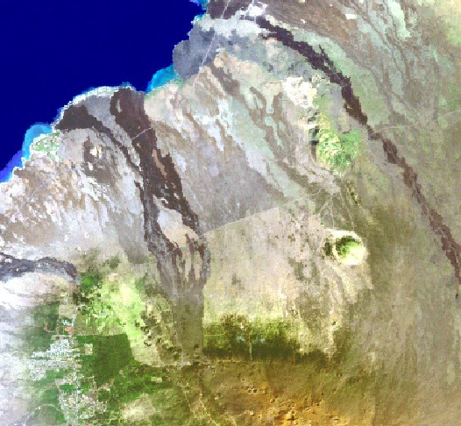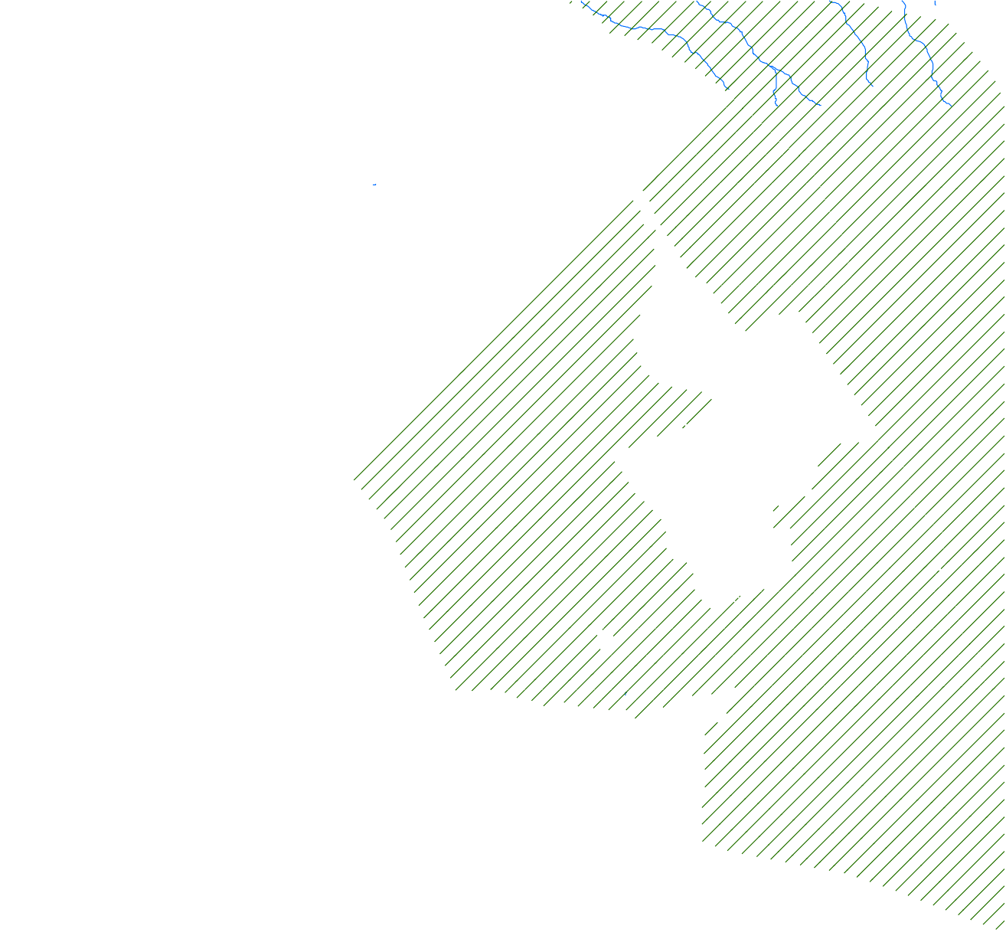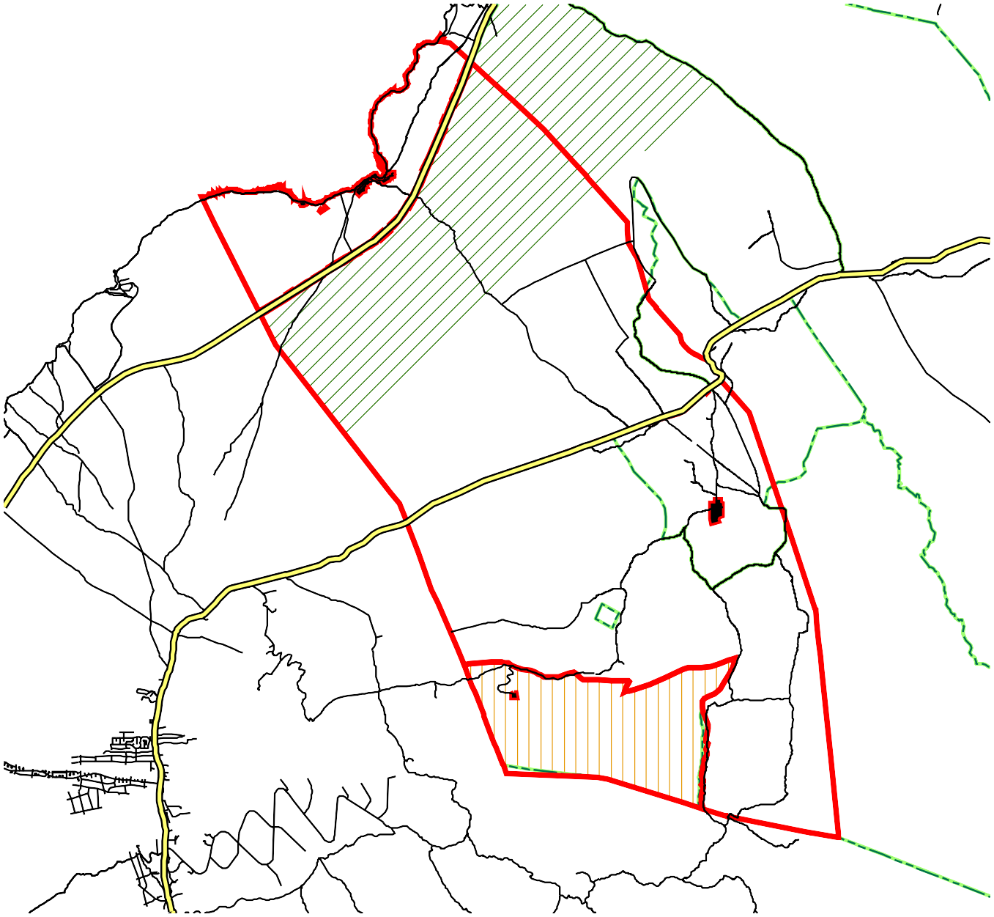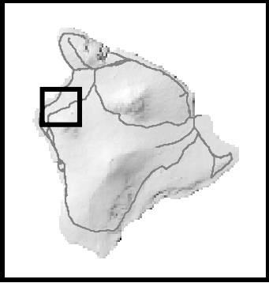
Data Source : Landsat, State of Hawaii GIS.

